Ministerul Educaţiei, al Culturii și Cercetării al Republicii Moldova

Universitatea Tehnică a Moldovei

Departamentul Informatică și Ingineria Sistemelor

RAPORT

Lucrarea de laborator nr.2
Metode și Modele de Calcul

A efectuat:
st. gr. C-171 D. Melniciuc

A verificat:
Lect. univ. D. Istrati

Chişinău 2018

Scopul lucrarii practice:

Sa rezolvesistemul de ecuatii liniare Ax = b utilizind:
Metoda eliminatii Gauss
Metoda lui Cholesky
Metoda iterative a lui Jacobi
Metoda iterative Gauss-Seidel

ScreenShot-uri:

Metoda Jacobi Metoda Cholesky
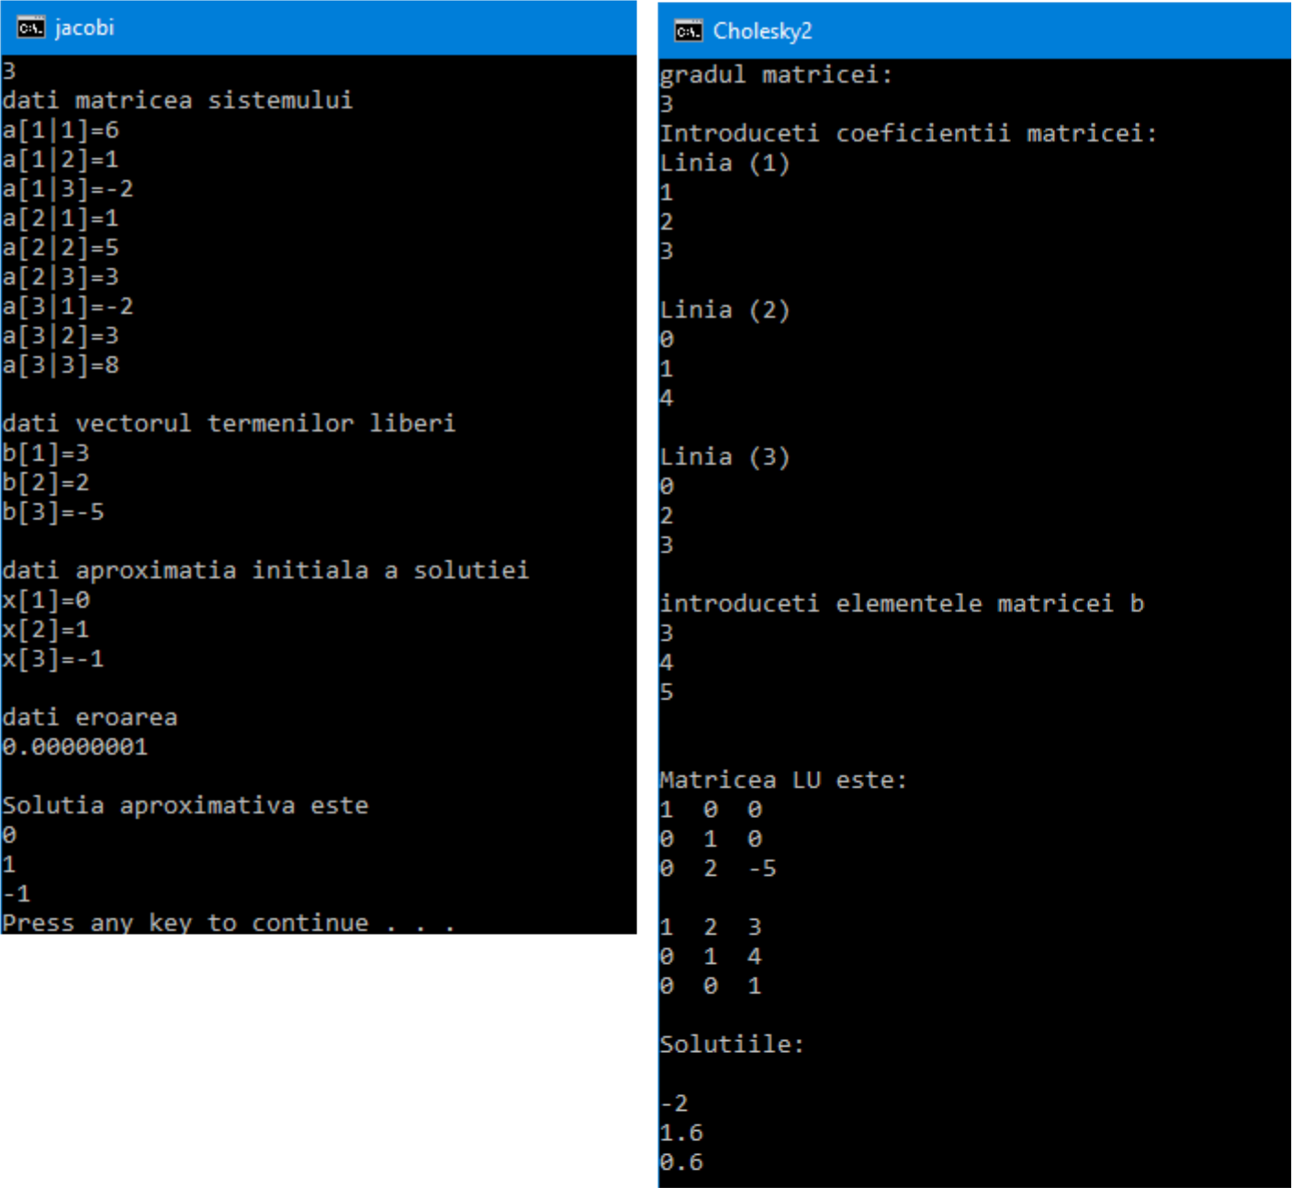
Metoda Gauss – Seidel Metoda Gauss
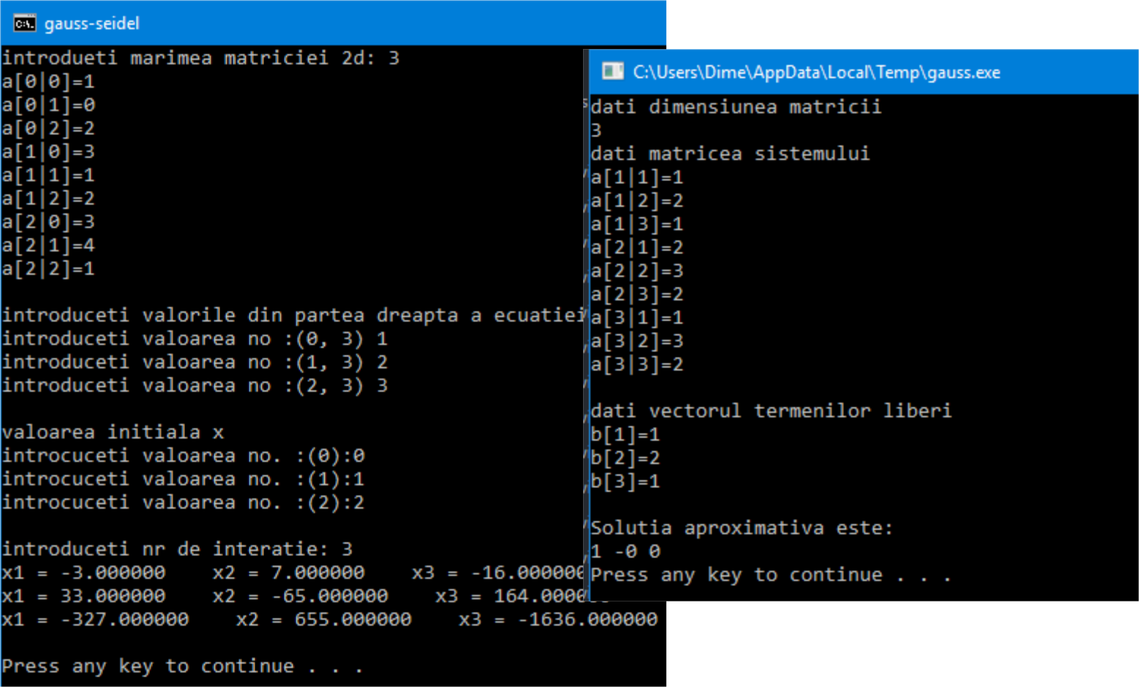

Codul programului:

Metoda Gauss – Seidel

#include<iostream> | }
#include<conio.h> | }
using namespace std; | cout << "\nintroduceti valorile din
int main(void) | partea dreapta a ecuatiei\n";
{ | for (i = 0; i < n; i++){
float a[10][10], b[10], x[10], | cout << "introduceti valoarea
y[10]; | no :(" << i << ", " << j << ") ";
int n = 0, m = 0, i = 0, j = 0; | cin >> b[i];
cout << "introdueti marimea | }
matriciei 2d: "; | cout << "\nvaloarea initiala x\n";
cin >> n;
for (i = 0; i < n; i++){ | for (i = 0; i < n; i++){
for (j = 0; j < n; j++) | cout << "introcuceti valoarea
{ | no. :(" << i<<"):";
cout << "a[" << i | cin >> x[i];
<<"|"<< j << "]="; | }
cin >> a[i][j];

cout << "\nintroduceti nr de interatie: ";
cin >> m;
while (m > 0){
for (i = 0; i < n; i++)
{
y[i] = (b[i] / a[i][i]);
for (j = 0; j < n; j++)
{
if (j == i)
continue;

Metoda Gauss

#include <iostream>
#include <math.h>
using namespace std;
#define max 15

int main(void)
{
float s;
float a[max + 1][max + 1] [max + 1], b[max + 1][max + 1], x[max + 1];
int n, i, j, k;
cout << "dati dimensiunea
matricii" << endl; cin >> n; cout << "dati matricea
sistemului " << endl;
for (i = 1; i <= n; i++)
for (j = 1; j <= n; j++){ cout << "a[" << i
<<"|"<< j << "]=";
cin >> a[i][j][1];
}

cout << endl;
cout << "dati vectorul termenilor liberi " << endl;

for (i = 1; i <= n; i++){ cout << "b[" << i <<

"]=";
y[i] = y[i] - ((a[i][j] / a[i] [i]) * x[j]);
x[i] = y[i];
}
printf("x%d = %f ", i + 1,
y[i]);

}
cout << "\n";
m--;
}
return 0;

}

}

cout << endl;
for (k = 1; k <= n - 1; k++){

for (i = 1; i <= n; i++) for (j = 1; j <= n; j++){ if (i <= k)a[i][j][k
+ 1] = a[i][j][k];
else if (j <= k)a[i]
[j][k + 1] = 0;
else a[i][j][k + 1]
- a[i][j][k] - a[i][k][k] * a[k][j][k] / a[k][k][k];
}
for (i = 1; i <= n; i++) if (i <= k)b[i][k + 1] =

b[i][k];
else b[i][k + 1] = b[i][k]

- a[i][k][k] * b[k][k] / a[k][k][k];
}

x[n] = b[n][n] / a[n][n][n];

for (i = n - 1; i >= 1; i--)
{
s = 0;
for (j = i + 1; j <= n; j+
+)
s = s + a[i][j][i] *
x[j];

cin >> b[i][1];

x[i] = (b[i][i] - s) / a[i]
[i][i];
}cout << "Solutia aproximativa este:" << endl;

Metoda Jacobi

#include <iostream>
#include <math.h>
using namespace std;

#define max 10

int main()
{
float s, s1, eps;
float a[max + 1][max + 1], b[max + 1], x[max + 1], y[max + 1];

int n, i, j;
cout << "dati numarul de ecuatii si necunoscute " << endl;
cin >> n;
cout << "dati matricea sistemului " << endl;

for (i = 1; i <= n; i++) for (j = 1; j <= n; j++){ cout << "a[" << i
<<"|"<< j << "]=";
cin >> a[i][j];
}
cout << endl;
cout << "dati vectorul termenilor liberi " << endl;

for (i = 1; i <= n; i++){ cout << "b[" << i <<

"]=";
cin >> b[i];
}
cout << endl;

Metoda Cholesky

#include <iostream>
#include <conio.h>
using namespace std;
int main()
{
for (i = 1; i <= n; i++) cout << x[i] << ' ';

cout << endl;
system("pause");
}
cout << "dati aproximatia initiala a solutiei " << endl;

for (i = 1; i <= n; i++){ cout << "x[" << i <<

"]=";
cin >> y[i];
}
cout << endl;
cout << "dati eroarea " << endl; cin >> eps; cout << endl;

s = eps + 1;
while (s >= eps){
for (i = 1; i <= n; i++)
{
s1 = 0;
for (j = 1; j <= n;
j++)
if (j != i)s1 = s1 +
a[i][j] * y[j]; x[i] = (b[i] - s1) / a[i]
[i];
}
s = 0;
for (i = 1; i <= n; i++) s = s + abs(x[i] -
y[i]);
for (i = 1; i <= n; i++)
y[i] = x[i];
}
cout << "Solutia aproximativa este " << endl;
for (i = 1; i <= n; i++) cout << x[i] << endl;
system("pause");
}

int n,i,k,j,p;
float a[10][10],l[10][10]={0},u[10] [10]={0},sum,b[10],z[10]={0},x[10]={0};

- clrscr();
cout<<"gradul matricei: "<<endl;

cin>>n;
{

";

cout<<"Introduceti coeficientii matricei:

for(i=1;i<=n;i++)
for(j=1;j<=n;j++)
cout<<l[i][j]<<" ";
cout<<endl;

{

cout<<"\nLinia ("<<i<<") \n";
for(j=1;j<=n;j++)
cin>>a[i][j];
}
cout<<endl;
for(i=1;i<=n;i++)

{

}
cout<<"\nintroduceti elementele matricei

b"<<endl;
for(j=1;j<=n;j++)
cout<<u[i][j]<<" ";
cout<<endl;

for(i=1;i<=n;i++)

}

cin>>b[i];

for(k=1;k<=n;k++)
{
u[k][k]=1;
for(i=k;i<=n;i++)
{
sum=0;
for(p=1;p<=k-1;p++)

for(i=1;i<=n;i++)
{
subtitution method
sum=0;
for(p=1;p<i;p++)
sum+=l[i][p]*z[p];
z[i]=(b[i]-sum)/l[i][i];

//forward

sum+=l[i][p]*u[p][k];

}

l[i][k]=a[i][k]-sum;

}
for(i=n;i>0;i--)

{

for(j=k+1;j<=n;j++)
{
sum=0;
for(p=1;p<=k-1;p++)
sum=0;
for(p=n;p>i;p--)
sum+=u[i][p]*x[p];
x[i]=(z[i]-sum)/u[i][i];

sum+=l[k][p]*u[p][j];

}

}

}
u[k][j]=(a[k][j]-sum)/l[k][k];
cout<<endl<<"Solutiile: "<<endl;

for(i=1;i<=n;i++)
cout<<endl<<x[i];

//******** Displaying LU

matrix**********// cout<<endl<<endl<<"Matricea LU
getch();

return 0;

este: "<<endl;
}

for(i=1;i<=n;i++)

Concluzie:

In urma efectuarii laboratorului au fost obtinute anumite abilitati in domeniu MMC si rezolvarea sistemelor de ecuatie utilizind metodele eliminatii Gauss, metoda lui Cholesky. metoda iterative a lui Jacobi si metoda iterative Gauss-Seidel

